**Bank Giving Loan or Not Data Decision Tree**

* Import required model & data set for decision tree

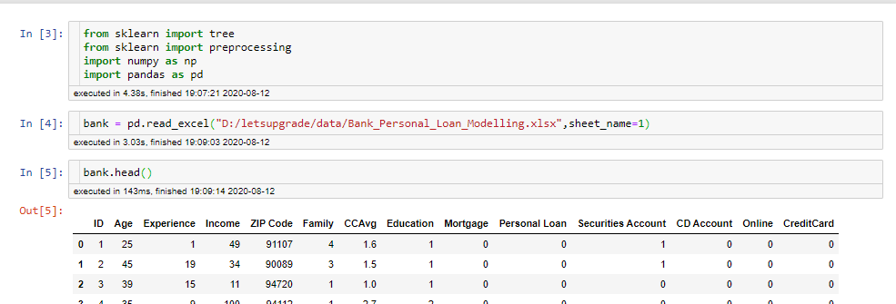

* Define dependent & independent variable for decision tree

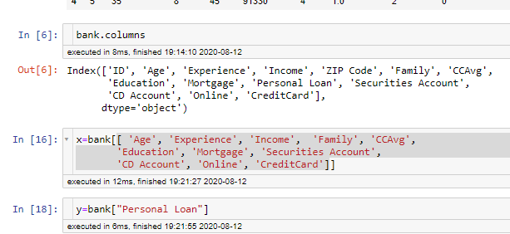

* Check if any null value is not present in data set

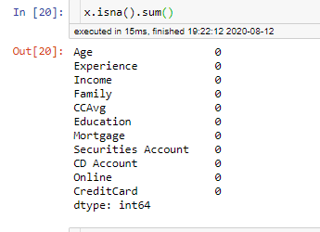

* Model form by all feature

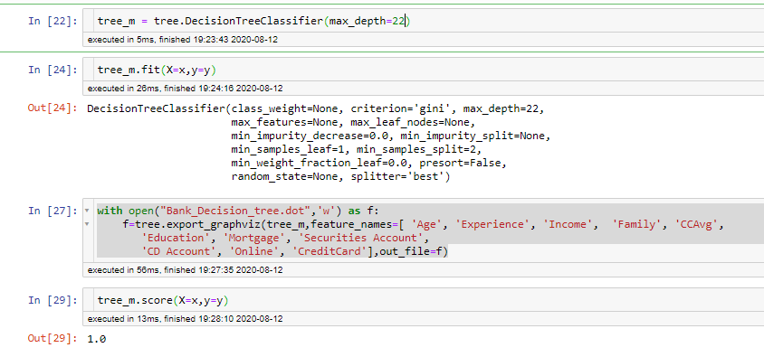

* The score value show that our model is over fit model we want to do select only important variable so we required to do pruning
* Apply Random Forest Algoritham for selected important feature for decision tree

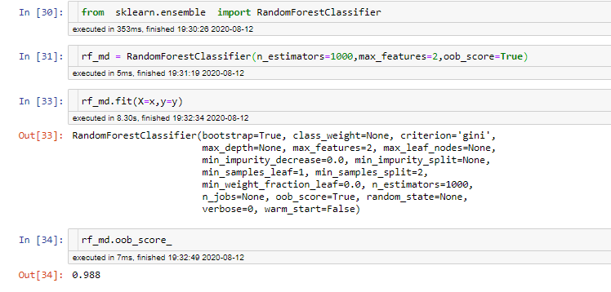

* The obb score denoted the homogeneity in our model is very high
* Important feature are

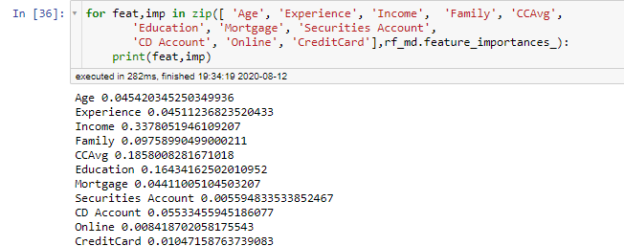

* important feature are three Income,CCAVG,Education
* by these three feature use we prepared decision tree

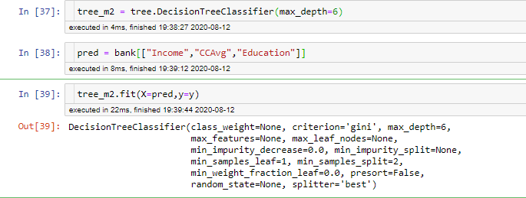

* save tree in dot file & draw at site <http://www.webgraphviz.com/>

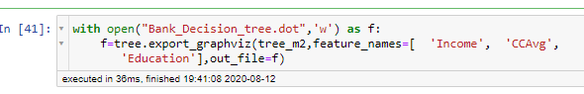

* Decision Tree

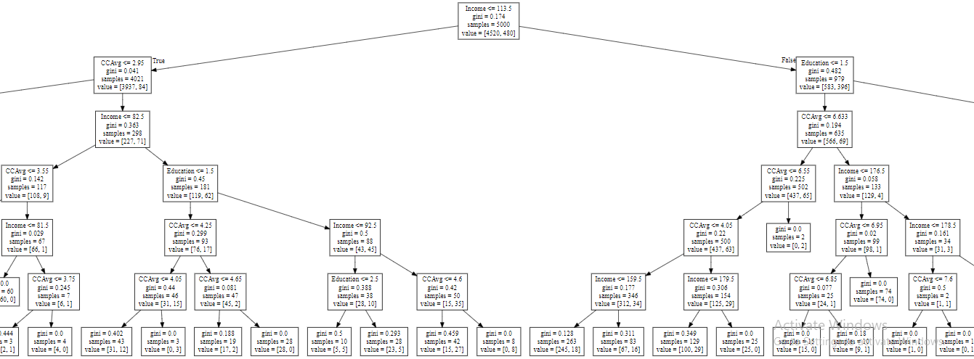

Personal loan : 0 –No no of person get loan = 480

1. Yes no. of person not get loan = 4520

Education Level. 1: Undergrad; 2: Graduate; 3: Advanced/Professional

1. income <=106.5 & CCAvg <=2.95 🡪not get loan
2. Income > 116.5 & Education >1.5 🡪get loan
3. Income > 116.5 & Education >1.5 & CCAvg < =0.55🡪get loan
4. Income > 116.5 & income<114.5 & Education >1.5 & CCAvg >=0.55 🡪not get loan

Smilarliy all rule is formed